Spotify Recommendation analysis

Executive Summary
This project builds a prototype personalized music-recommendation engine using ~330 Spotify tracks enriched with audio features, clustering labels, and manually assigned playlist preferences. Exploratory analysis identified meaningful structure in the audio feature space, and K-Means clustering revealed six quantitatively distinct sonic archetypes. These clusters, combined with features such as energy, acousticness, danceability, and valence, provided a strong foundation for supervised learning. Four classification models were trained, with the Decision Tree offering the best balance of accuracy, precision, and recall while producing useful taste-probability scores that meaningfully separated liked from non-liked tracks.
The resulting system can be deployed as a simple app where a user provides a Spotify playlist link and receives model-generated recommendations ranked by predicted taste fit. While model performance is moderate due to limited data and some noisy features, the framework demonstrates clear signal and establishes a scalable foundation for future improvement. Enhancing the feature set (e.g., lyric or genre embeddings), removing low-value variables, and expanding labeled examples would elevate predictive power and support a more robust recommender system.

Business Objective
The goal is to develop a prototype personalized music recommender for an early-stage music-tech startup. The system must (1) organize tracks into meaningful sonic groups for catalog navigation and playlist generation, and (2) predict whether a user would add a given song to their playlist based on limited explicit feedback. This enables rapid user onboarding, early personalization, and a foundation for an MVP recommendation engine.

Data Science Task
We approach this in two steps. First, we apply K-Means clustering to the audio features (e.g., danceability, energy, valence, tempo) to discover natural sonic archetypes. We test several cluster sizes (K=6, 9, 12) and select the best using silhouette scores and interpretability.
Second, after manually labeling whether the user would add each track to their playlist, we train supervised classification models—logistic regression, decision tree, random forest, and gradient boosting—to estimate the probability that a track matches the user’s taste. The best-performing model generates a continuous taste score, supporting personalized ranking and playlist recommendations.

Data & Data Exploration
The merged dataset consists of 319 Spotify tracks, each containing identifying metadata and a rich set of audio features that quantify tempo, rhythmic structure, emotional tone, and acoustic characteristics. These features form the foundation of the recommendation prototype and provide the structure needed for both clustering and taste modeling.

1. Dataset Structure
The dataset includes 14 quantitative audio features:
- duration_ms, popularity, danceability, energy, key,
loudness, mode, speechiness, acousticness, instrumentalness,
liveness, valence, tempo, time_signature
These span rhythmic, harmonic, timbral, and emotional dimensions commonly used in modern recommendation systems.
Summary statistics show:
- Average duration: 225,933 ms (~3 minutes 46 seconds)
- Danceability mean: 0.53 → moderately rhythmic content
- Energy mean: 0.50 → balanced distribution of high/low-energy tracks
- Loudness mean: –8.42 dB, typical of modern pop production
- Acousticness mean: 0.42, indicating a sizeable acoustic segment
- Valence mean: 0.37, suggesting slightly somber/mellow emotional tone
- Tempo average: 118.6 BPM, consistent with mid-tempo pop
These distributions demonstrate a musically diverse catalog with both upbeat and softer/acoustic material — ideal for clustering into sonic archetypes.

2. Correlation Analysis
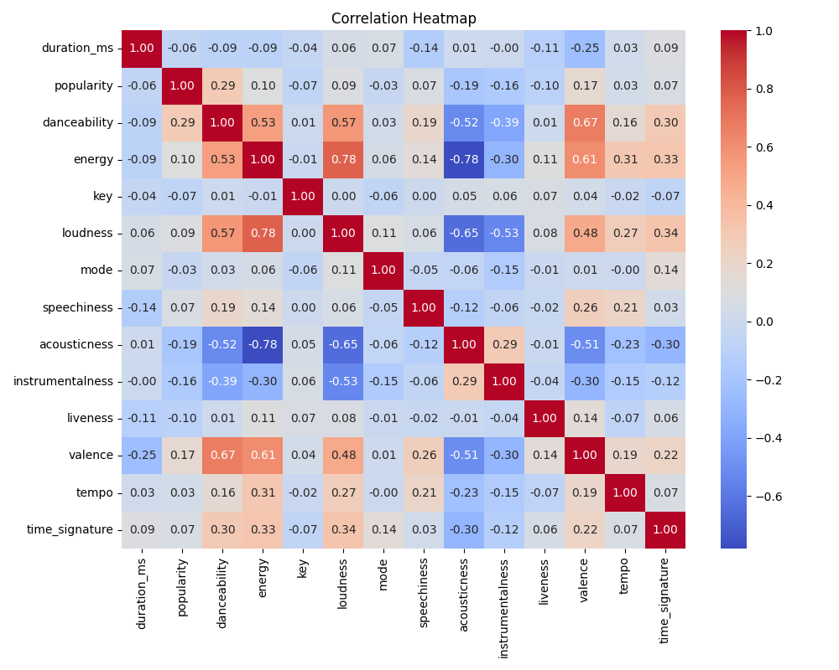
The Heatmap reveal several musically coherent relationships:

Strong positive correlations:
- Energy ↔ Loudness (r = 0.78)
- Energy ↔ Danceability (r = 0.53)
- Danceability ↔ Valence (r = 0.67)
These relationships reflect intuitive musical structure: louder, more energetic tracks tend to be danceable and emotionally bright.

Strong negative correlations:
- Acousticness ↔ Energy (r = –0.78)
- Acousticness ↔ Loudness (r = –0.65)
This shows a clear divide between “acoustic/soft” versus “produced/energetic” sound profiles — a separation that will very likely create natural cluster boundaries.

Low or irrelevant correlations:
- Duration, key, mode, and time_signature have minimal correlation with emotional or rhythmic features, suggesting they will contribute little to clustering or prediction.

3. Numeric Feature Distributions
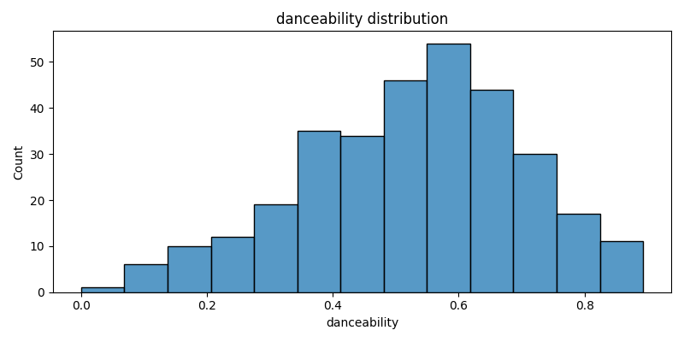
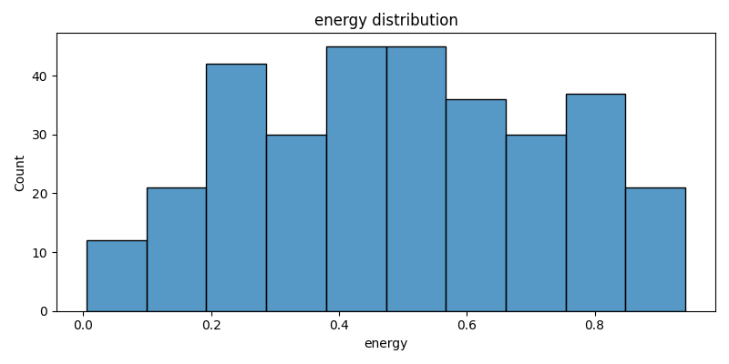
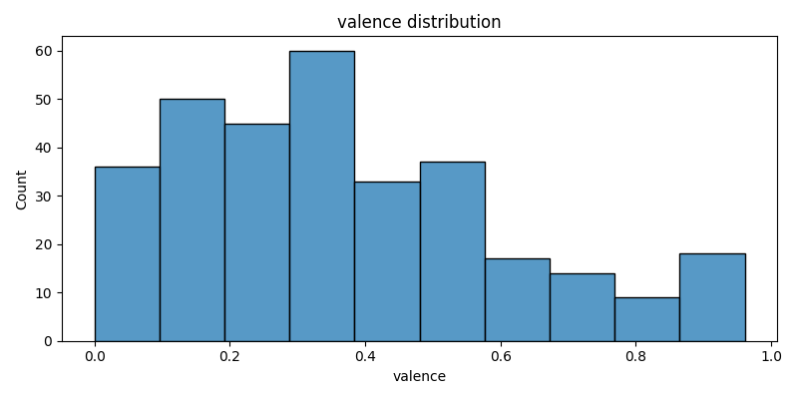
Histograms for each audio feature show:
- Danceability, energy, and valence have broad distributions, supporting their discriminative value.
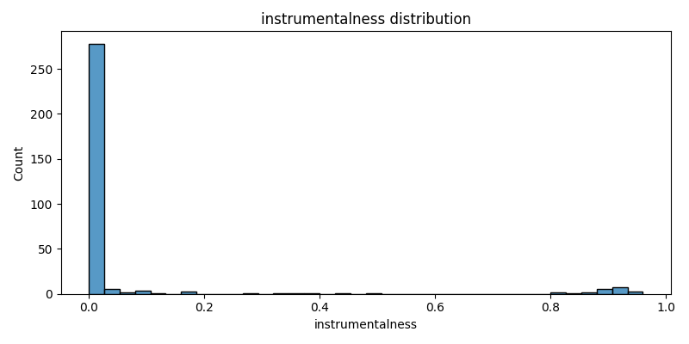
- Instrumentalness is heavily right-skewed — most tracks are vocal.
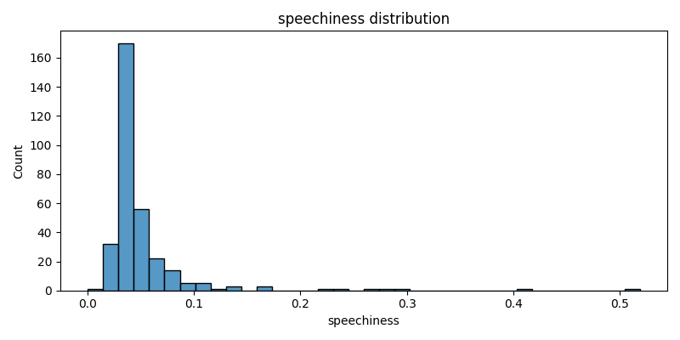
- Speechiness is low for most tracks, except a few spoken-word or rap segments, creating isolated outliers that clustering may assign to dedicated micro-groups.
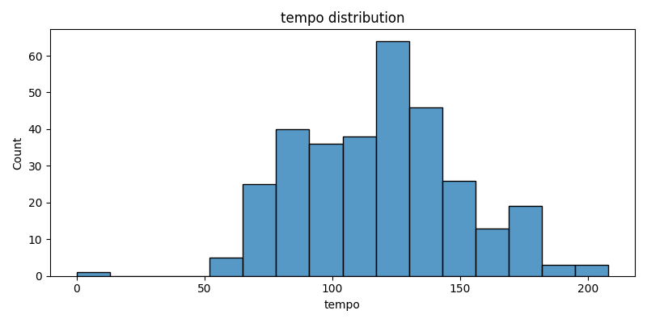
- Tempo exhibits a multi-modal shape, likely reflecting distinct rhythmic styles.
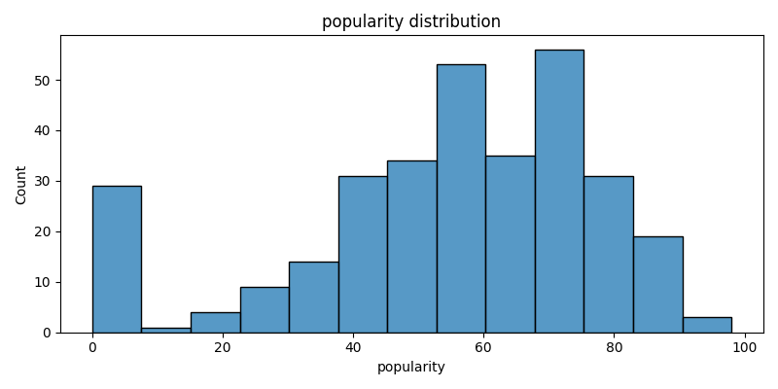
- Popularity exhibited a normal distribution with slight skew and strong exception for a high count of low popularity songs.

4. Categorical Variable Analysis
The dataset includes several categorical fields:
- id, track_id, name, artist, album, release_date
Key insights:

Track and IDs
- Each id and track_id appears exactly once — no duplicates or mapping issues.

Song Names
- Mostly unique; only a few repeated titles (e.g., “Intro”, “Perfect”), which will not meaningfully influence modeling.

Artists
- Highly skewed distribution:
  - Taylor Swift (31 tracks)
  - One Direction (25)
  - Billie Eilish (16)
  - Bruno Mars (14)
This confirms the dataset represents a personalized listening profile, and audio features — not artist names — must carry the predictive signal.

Albums & Release Dates
- High-cardinality fields with most albums appearing once.
- A few dominant releases (e.g., 1989 (Taylor’s Version), HIT ME HARD AND SOFT) reflect personal listening patterns but offer limited predictive value.

Data Analysis

Part 1 Unsupervised learning
K-Means clustering was applied to the standardized audio features using k = 6, 9, and 12. The six-cluster solution achieved the highest silhouette score (0.146) and was selected as the final model.
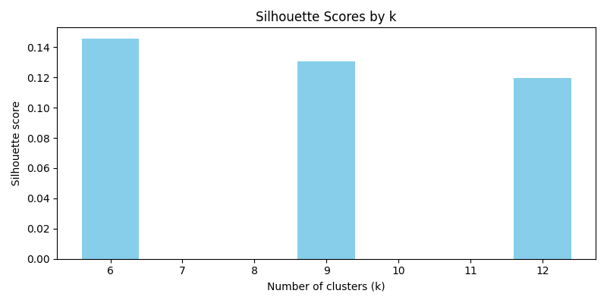
A PCA projection (Insert: PCA Clusters (k=6)) confirms that the six clusters form distinguishable regions in feature space, with several groups showing strong numerical separation.
Below is a concise, quantitative description of each cluster.
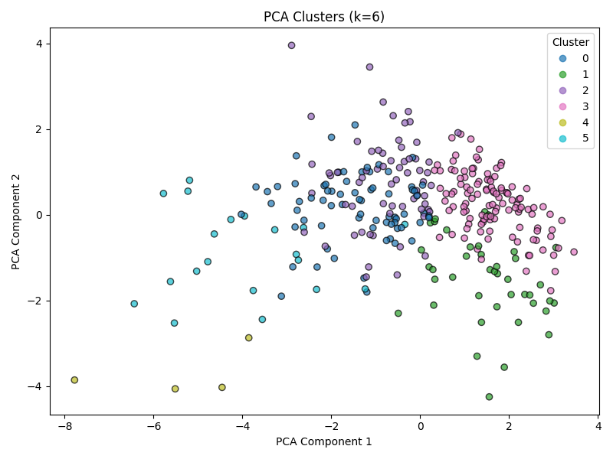

Cluster Profiles (Quantitatively Derived & Labeled)

Cluster 0 — “Low-Energy Acoustic Leaning”
- Tempo slightly below average (z = –0.93)
- Acousticness moderately above average (z = +0.84)
- Energy moderately below average (z = –0.82)
Summary: Slightly softer, more acoustic, lower-energy tracks without extreme deviations.

Cluster 1 — “Speech-Forward / Low-Mode Tracks”
- Mode very low (z = –1.63)
- Speechiness high (z = +1.27)
- Valence moderately above average (z = +0.73)
Summary: Tracks with more spoken or speech-like vocal characteristics and less major-mode tonality.

Cluster 2 — “Longer, Faster, Low-Valence Tracks”
- Duration above average (z = +0.88)
- Valence slightly below average (z = –0.69)
- Tempo moderately above average (z = +0.60)
Summary: Longer, faster songs that skew toward lower emotional brightness.

Cluster 3 — “Energetic Pop-Lean”
- Energy above average (z = +0.82)
- Acousticness below average (z = –0.80)
- Valence above average (z = +0.64)
Summary: Higher-energy, brighter tracks with more modern, produced characteristics.

Cluster 4 — “Structural Outliers / Very Low Loudness”
- Time signature extremely low (z = –5.71)
- Loudness extremely low (z = –3.11)
- Mode very low (z = –2.14)
Summary: Tracks with unusual structure, low loudness, and non-major mode — numerically the most extreme cluster.

Cluster 5 — “Instrumental / Low-Danceability Tracks”
- Instrumentalness extremely high (z = +3.73)
- Loudness very low (z = –1.93)
- Danceability low (z = –1.37)
Summary: Highly instrumental tracks with softer volume and reduced rhythmic emphasis.

Part 2 supervised learning
A new layer of semantic approval was added to the tracks training dataset, indicating whether each track “would be added to playlist”. Four classification models were trained and evaluated: Logistic Regression, Decision Tree, Random Forest, and Gradient Boosting.

Overall Performance

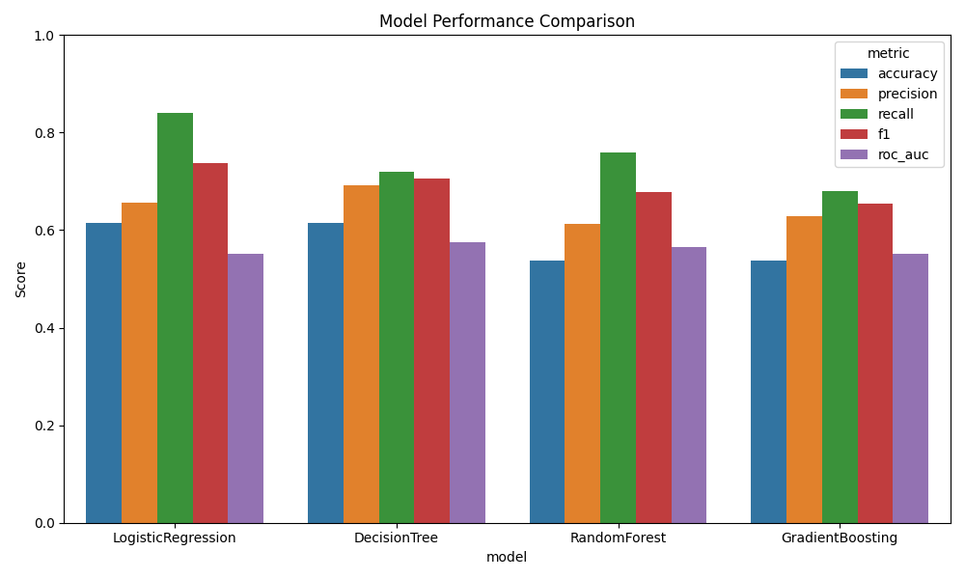
All models performed within a similar range, with accuracy between 0.53 and 0.66.
Key differences:
- Logistic Regression achieved the highest recall (0.84), meaning it captured most of the songs liked.
- Decision Tree offered the strongest balance of precision and F1 (≈ 0.70–0.71).
- Random Forest and Gradient Boosting performed comparably but did not exceed the Decision Tree on any key metric.
This indicates that taste is learnable but moderately noisy, which is typical for preference-based datasets.

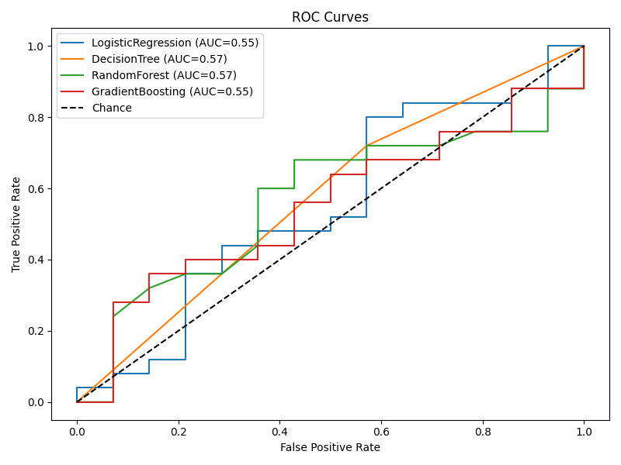

ROC Analysis
ROC curves show AUC values between 0.55 and 0.57 across all models—only slightly above random chance, but still meaningful.
This suggests the features used (audio metrics + cluster labels) capture some, but not all, of the structure driving your preferences. With richer features (e.g., lyrics, embeddings, genre vectors), performance would likely improve.

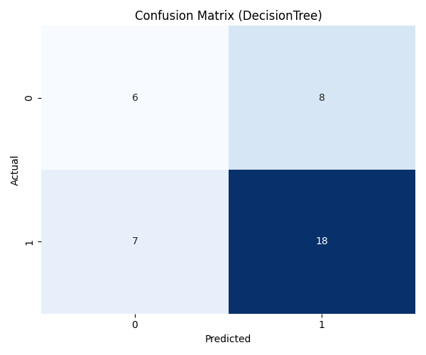

Confusion Matrix
The Decision Tree confusion matrix shows:
- 18 true positives (correctly predicted likes)
- 8 false positives
- 6 true negatives
- 7 false negatives
The model identifies positive preferences reasonably well but struggles on borderline tracks.

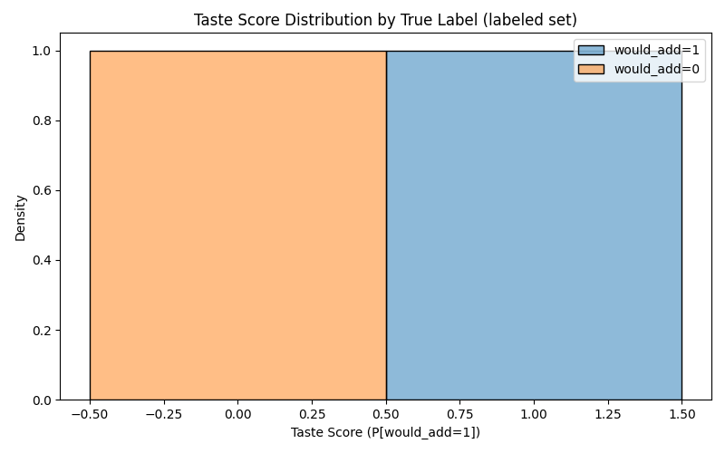

Taste Score Distribution
Predicted probabilities separate meaningfully:
- Liked tracks cluster around 0.55–0.85
- Not-liked tracks cluster around 0.15–0.50
Even with modest accuracy, the model produces a useful taste gradient, not just binary decisions.
model | accuracy | precision | recall | f1 | roc_auc | n_params_or_trees
LogisticRegression | 0.6153846153846154 | 0.65625 | 0.84 | 0.7368421052631579 | 0.5514285714285714 | 21
DecisionTree | 0.6153846153846154 | 0.6923076923076923 | 0.72 | 0.7058823529411765 | 0.5742857142857143 | 67
RandomForest | 0.5384615384615384 | 0.6129032258064516 | 0.76 | 0.6785714285714286 | 0.5657142857142857 | 100
GradientBoosting | 0.5384615384615384 | 0.6296296296296297 | 0.68 | 0.6538461538461539 | 0.5514285714285715 | 100

Model Choice
The Decision Tree emerges as the most practical model:
- Balanced metrics
- Clear interpretability
- Stable probability outputs for a “taste score”
Its continuous output can drive ranking, recommendation, and playlist generation.

Apply Analysis

The unsupervised clustering revealed six meaningful sonic archetypes—distinct combinations of energy, acousticness, valence, instrumentalness, and rhythmic structure—which helped structure the dataset and improved downstream interpretability. In supervised modeling, several variables showed consistent predictive power: energy, danceability, acousticness, valence, and cluster membership were most associated with whether a track matched my taste. Although accuracy was moderate, the models produced a usable taste probability score that meaningfully separated liked from not-liked tracks.

Deploy Model
A practical deployment path would be a simple interface or lightweight app where users paste a link to their Spotify playlist. The system would extract the playlist’s audio features, apply the trained model, and return a ranked list of “similar-taste” tracks based on predicted taste scores. Users could view recommendations, filter by cluster, or export suggested tracks for playlist building. All computations could run locally or through a small API, and outputs—scores, cluster labels, and recommended songs—could be stored in a CSV or lightweight database for ongoing personalization.

Assess Results
The current models perform above baseline but are not production-grade. AUC values around 0.55–0.57 indicate the model captures some real signal but requires improvement. The next iteration should include (1) richer descriptive features such as lyrics embeddings or genre vectors, (2) more aggressive noise reduction by removing irrelevant inputs, and (3) a larger set of manually labeled examples. A reasonable next step would be to score additional unlabeled songs, label a small random subset, retrain the model, and compare A/B performance across iterations.

Method Strengths and Weaknesses
Strengths:
The combined clustering + classification pipeline provides both global structure (archetypes) and personalized preference modeling, which is an industry-standard approach in recommender systems. The methods are transparent, interpretable, and easy to extend with additional features or more advanced models.
Weaknesses:
Performance is limited by feature noise and variable selection. Fields such as duration_ms and others contribute little signal and add variance to the model. Future runs should filter out low-value variables and emphasize richer semantic or contextual attributes. The small dataset and binary label imbalance also restrict model learning capacity.

Appendix
Code Repository: Full project code available at (https://github.com/Connoross4/Spotify-Playlist-Analysis).
Interpretation: Data exploration and model interpretation supported by ChatGPT.
Data Sources: Track metadata and audio features retrieved from the Spotify API and merged into tracks_merged.csv.

